CERTIGEN: AUTOMATED CERTIFICATE GENERATION AND MANAGEMENT SYSTEM
PROJECT DOCUMENTATION
24MNC201



SUBMITTED BY: Agnes Benoy
ROLL NUMBER: 12
INSTITUTION: AMAL JYOTHI COLLEGE OF ENGINEERING KOOVAPPALIY
PROJECT TITLE: CertiGen – Automated Certificate Generation and Management System

TOOLS USED: Microsoft Excel, Microsoft Word, Mail Merge, and PDF Export

1. System Description
CertiGen is a certificate generation system developed using Microsoft Excel and Microsoft Word. It uses the Mail Merge feature to generate personalized certificates from student information stored in an Excel worksheet.
The Excel workbook is used to organize student details and assessment results. Microsoft Word is used to design a certificate template containing placeholders for student-specific information. By connecting the Excel data source to the Word document, certificates can be generated for multiple students without manually preparing each certificate.
The system aims to reduce repetitive work, maintain consistent certificate formatting, and minimize errors caused by repeated manual data entry.
1.1 Main Components
Microsoft Excel: Stores student details and assessment information in a structured table.
Microsoft Word: Provides the certificate template and its layout.
Mail Merge: Connects the Excel worksheet to the Word template and inserts the appropriate student details into each certificate.
PDF Export: Can be used to save the generated certificates in PDF format, if included in the final implementation.
1.2 System Requirements
- A computer or laptop.
- Microsoft Excel.
- Microsoft Word with Mail Merge support.
- Student information organized in an Excel worksheet.
- A prepared certificate template.

2. Mail Merge Procedure
The following steps describe the procedure for generating certificates using Mail Merge.
Step 1: Prepare the Excel Data Source
Create an Excel worksheet containing the required student details. Each column should have a clear heading, and each row should represent one student.
Example fields include:
- Student Name
- Department
- Workshop
- Assessment Marks
- Grade
- Result
Screenshot 1: Student Data in Microsoft Excel
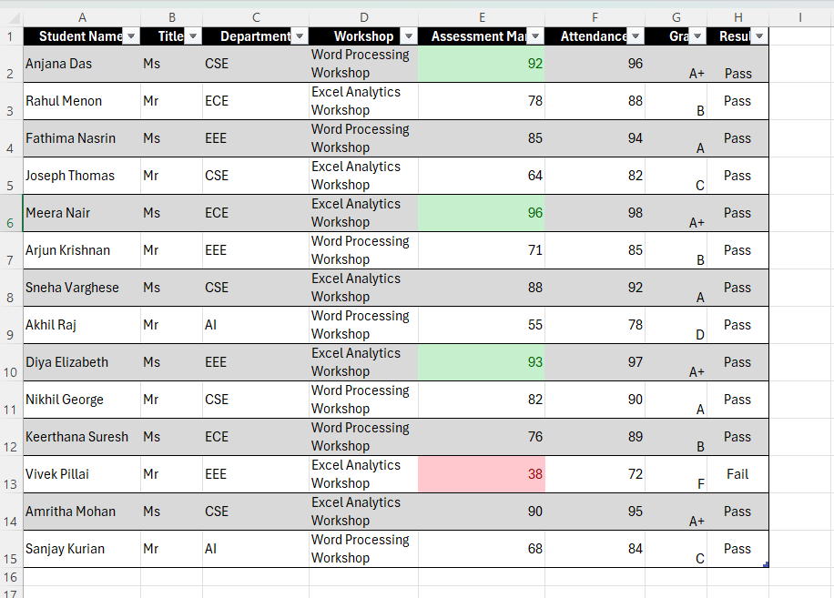Figure 1: Student information organized in an Excel worksheet.
Step 2: Design the Certificate Template
Open Microsoft Word and create the certificate layout. Add the certificate title, student details, workshop information, and other relevant text. Leave appropriate spaces for personalized information.
Screenshot 2: Certificate Template in Microsoft Word
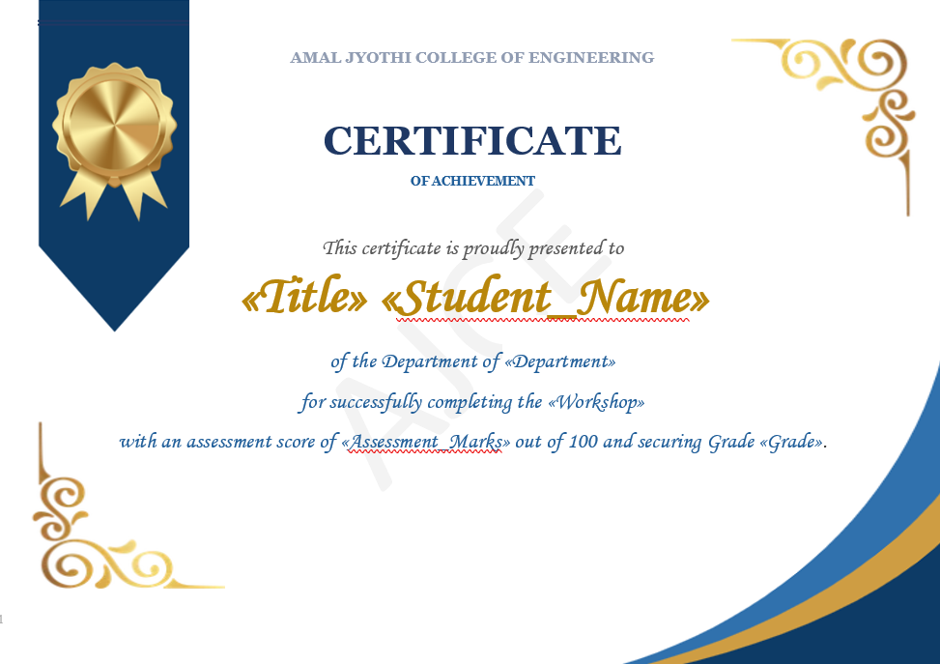
Figure 2: Certificate template designed in Microsoft Word.
Step 3: Start Mail Merge
Open the certificate document in Word. Navigate to the Mailings tab, select Start Mail Merge, and choose the appropriate document type, such as Letters, depending on the template setup.
Step 4: Select the Excel Data Source
Choose Select Recipients → Use an Existing List. Browse to the Excel workbook and select the worksheet containing the student records.
Step 5: Insert Merge Fields
Place the cursor where each personalized detail should appear. Use Insert Merge Field to insert the corresponding Excel column fields, such as Student_Name, Department, Workshop, Assessment_Marks, and Grade.
Step 6: Preview the Certificates
Select Preview Results to check how the student information appears in the certificate. Move through the records to verify that the details are inserted correctly.
Screenshot 3: Mail Merge Fields and Preview Results
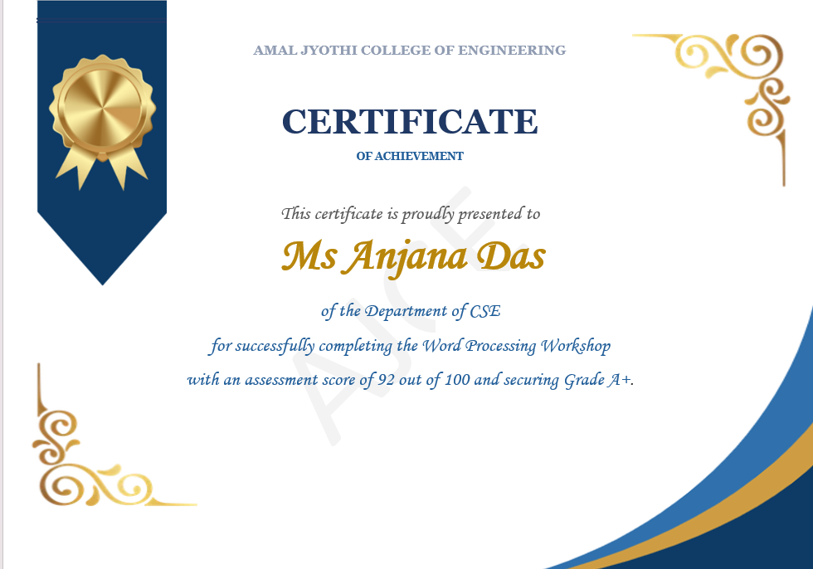
Figure 3: Personalized student details displayed using Mail Merge.
Step 7: Filter Records if Required
If certificates are intended only for eligible students, use Edit Recipient List to filter the records according to the required condition, such as Result = Pass. Apply this step only if the project uses result-based selection.
Step 8: Complete the Merge
Select Finish & Merge and choose the appropriate option to generate the certificates for the selected records.
Screenshot 4: Generated Certificates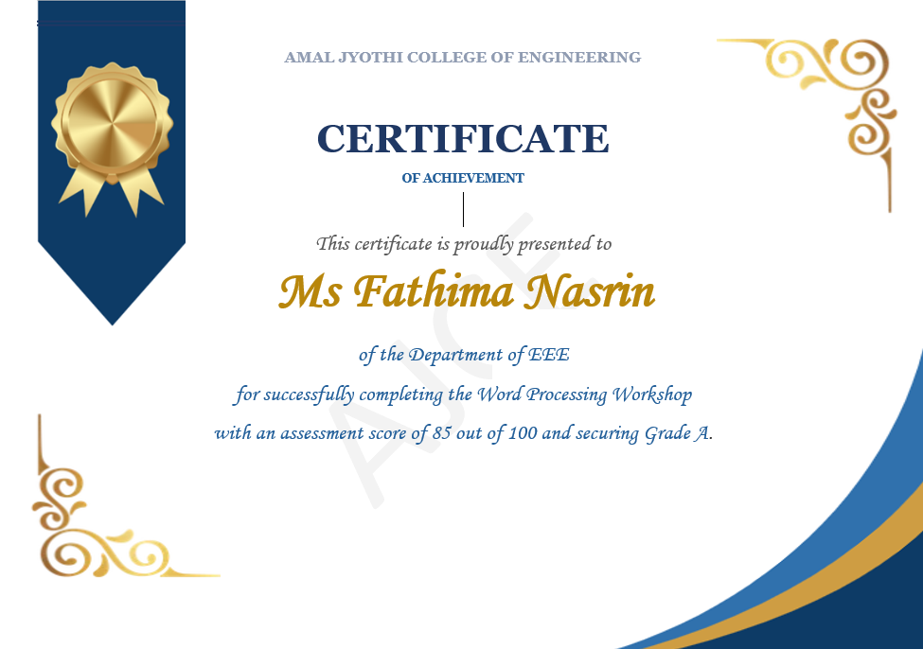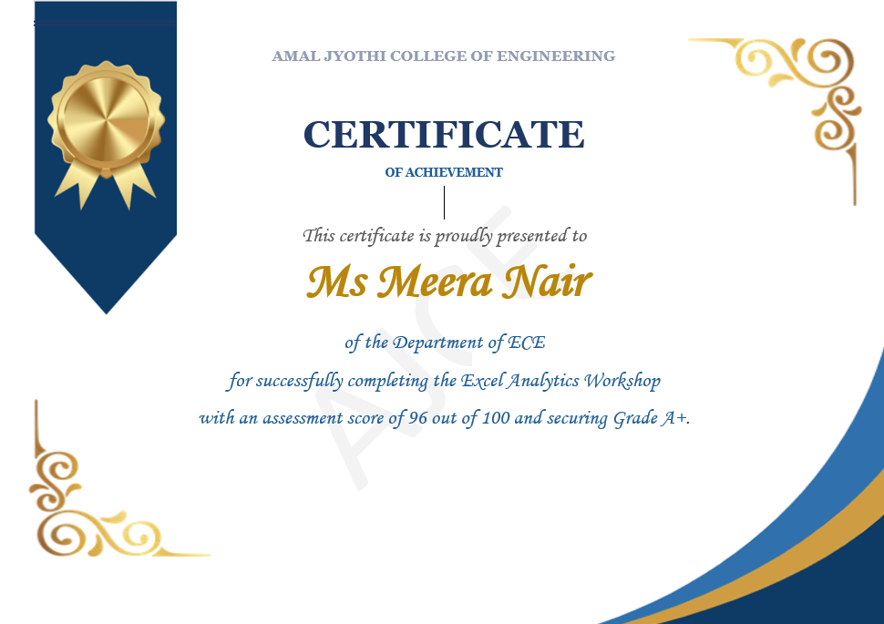
Figure 4: Certificates generated from the Excel data source.
Step 9: Save or Export the Output
Save the merged document. If PDF output is required and has been implemented, export the certificates to PDF and verify the final pages.

Screenshot 5: Saved Output or PDF Certificate
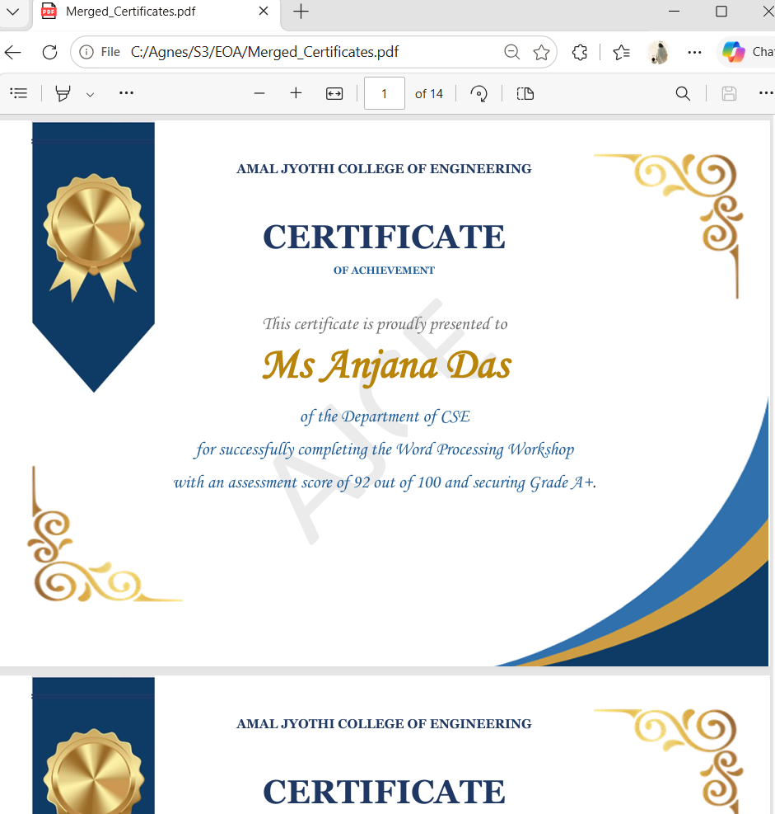Figure 5: Final certificate output.

3. Testing
Testing is performed to check whether the system generates certificates correctly and consistently.
Test Case | Testing Procedure | Expected Result
1. Excel data validation | Check the student records and column headings. | The data is organized correctly.
2. Data source connection | Connect the Excel workbook to Word. | Word recognizes the selected worksheet and records.
3. Merge field insertion | Insert the required fields into the template. | Each field corresponds to the correct column.
4. Certificate preview | Preview certificates for different students. | The correct student details appear in the template.
5. Record selection | Apply a filter if eligibility-based selection is used. | Only the intended records are selected.
6. Multiple certificate generation | Complete the merge for the selected records. | A personalized certificate is generated for each selected record.
7. Formatting verification | Check the layout, alignment, and text placement. | The certificate is readable and consistently formatted.
8. Output verification | Open the saved document or exported PDF. | The output opens correctly and contains the generated certificates.

3.1 Testing Results
Complete this section after testing the actual project.
- Data validation: [Pass/Fail]
- Mail Merge connection: [Pass/Fail]
- Correct field insertion: [Pass/Fail]
- Certificate generation: [Pass/Fail]
- Formatting verification: [Pass/Fail]
- PDF export, if implemented: [Pass/Fail/Not Applicable]

4. Screenshots
- Excel Student Data: Shows the student records and column headings.
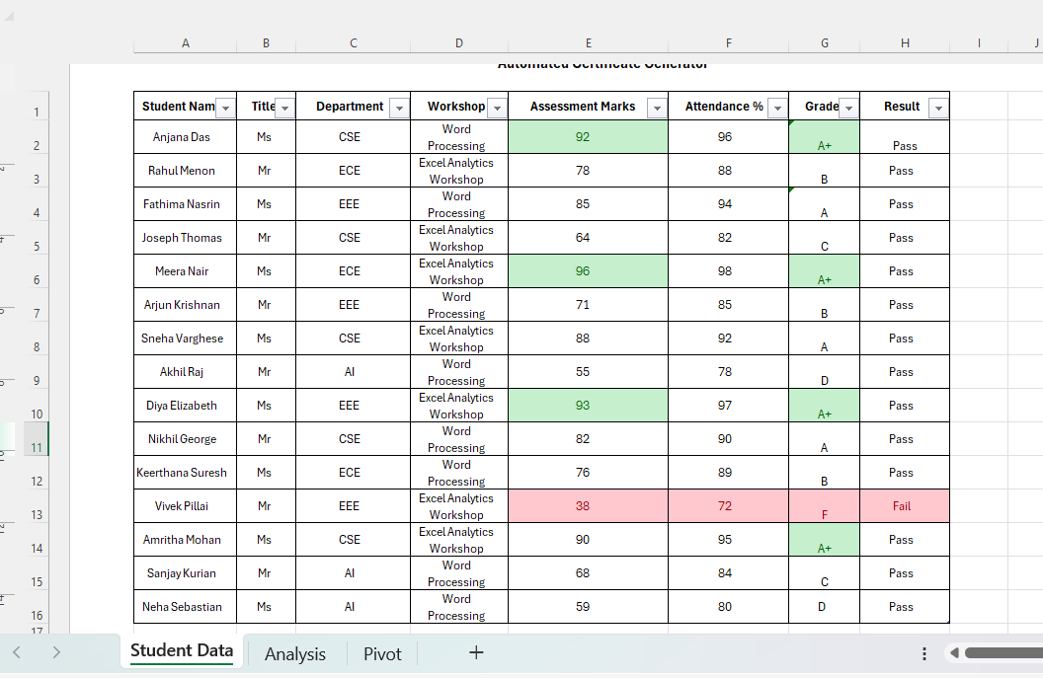
Figure 6: Excel Student Data.

- Excel Analysis: Shows any calculations or analysis included in the workbook.
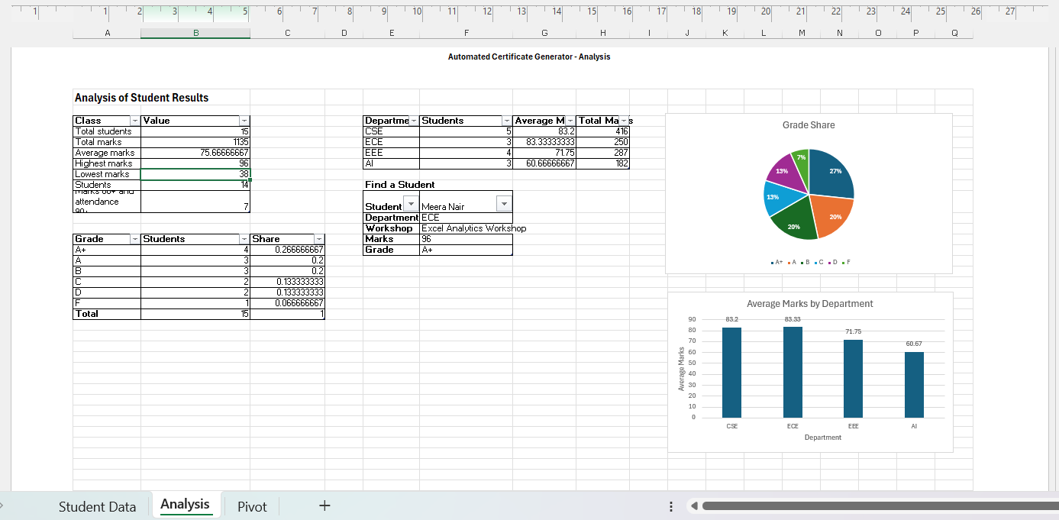
Figure 7: Excel Analysis.

- Word Certificate Template: Shows the certificate design before merging.
Figure 8: Word Certificate Template.

- Mail Merge Setup: Shows the selected data source and merge fields.
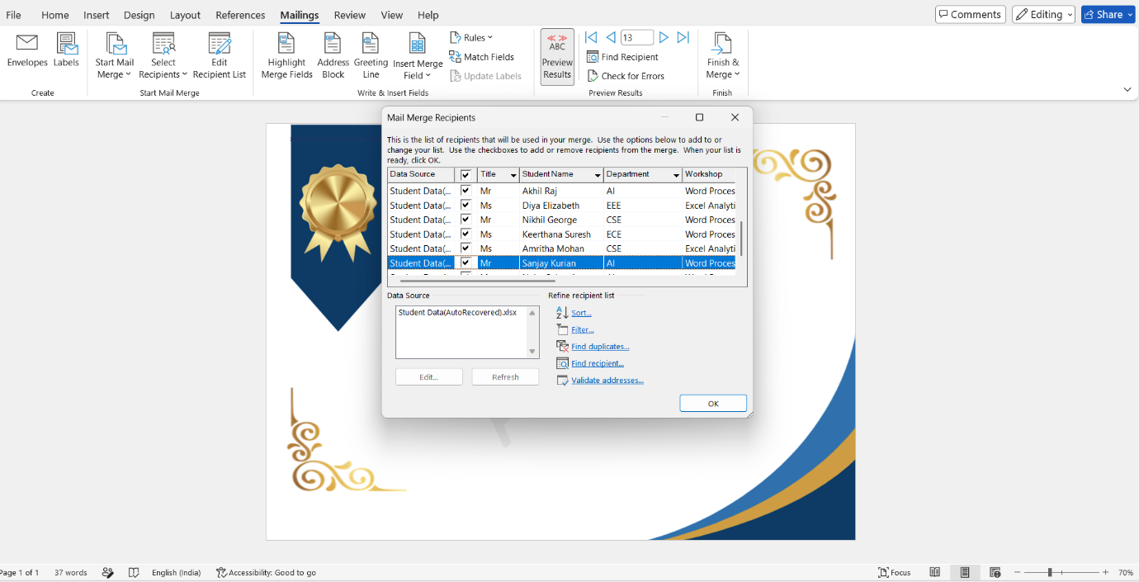
Figure 9: Word Certificate Template

- Preview Results: Shows a certificate populated with student details.
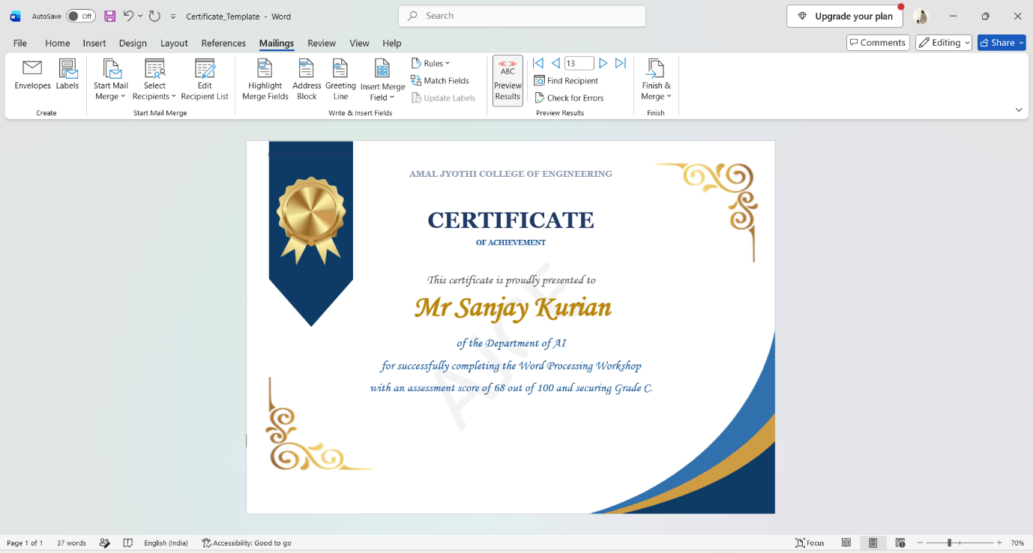
Figure 10: Preview Results

- Final Generated Certificates: Shows the completed merged output.
 | 
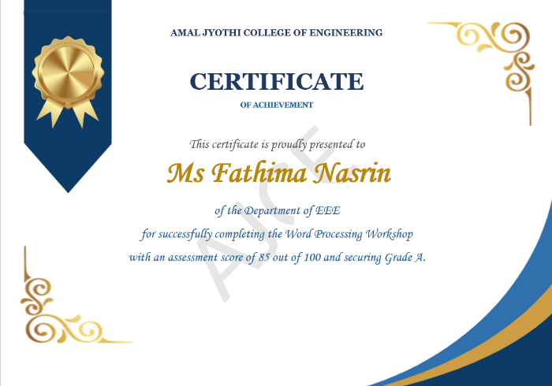 | 
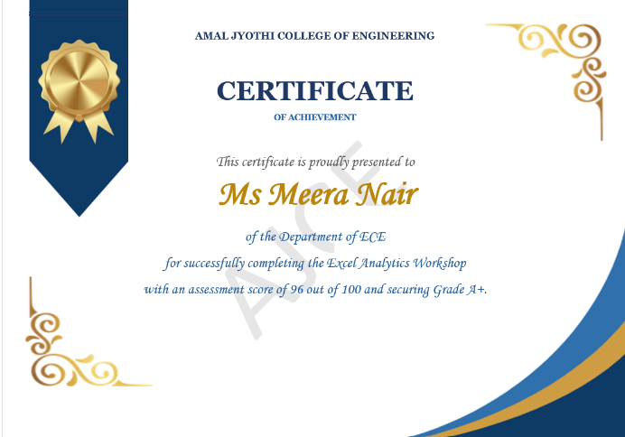 | 
 | 
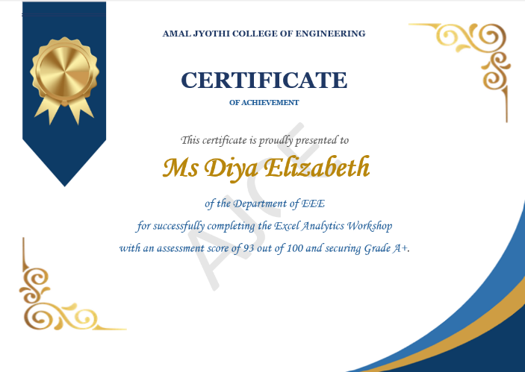 | 
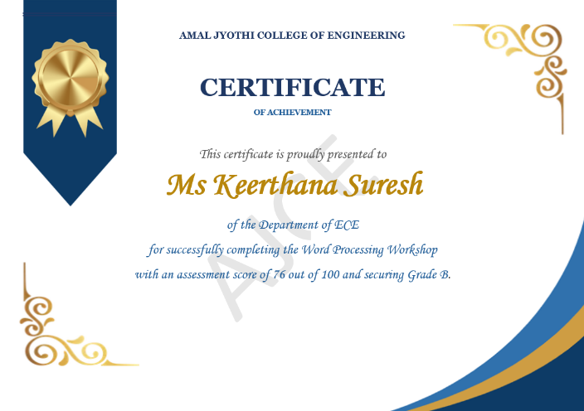 | 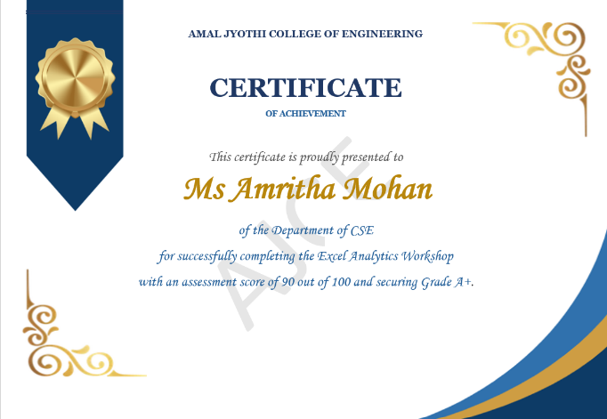
 | 

5. Conclusion
CertiGen demonstrates how Microsoft Excel, Microsoft Word, and Mail Merge can be used together to simplify certificate generation. The system uses structured student data and a reusable certificate template to generate personalized documents efficiently.
The project provides practical experience in spreadsheet organization, document formatting, data integration, and automated document generation. Testing and screenshots help demonstrate whether the implemented system meets its intended requirements.

